# Best Android Games

## The Wild Darkness

# **Source**: **Provided by** [Motasem Essam -> motasem.essam.prototypedoteg.com@gmail.com] **on** [10/9/2025]

# **Data Path**: Entities Folder -> 1-Entities Database -> 2-Persons Table -> ID: 1

**# Source: Windows Screenshots (using Lightshot Program) at [10/9/2025]**

[**https://play-lh.googleusercontent.com/cekAj4xsGkKxEzQIUGF0Mur24G27Vjaol-cmMFxKD17tPX5yVzcGpqlu_sc8Zsn11kQ**](https://play-lh.googleusercontent.com/cekAj4xsGkKxEzQIUGF0Mur24G27Vjaol-cmMFxKD17tPX5yVzcGpqlu_sc8Zsn11kQ)

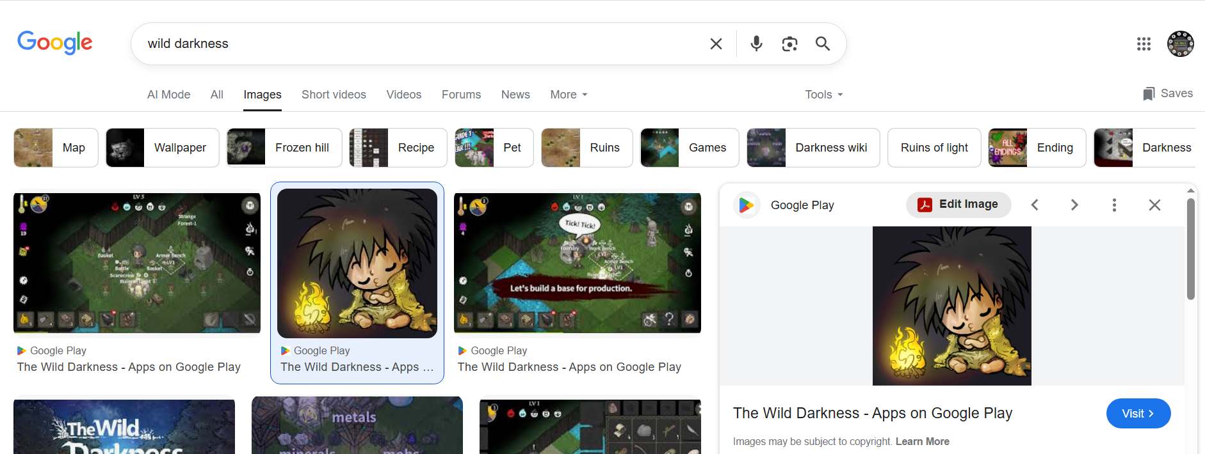



## OneBit Adventure

# **Source**: **Provided by** [Motasem Essam -> motasem.essam.prototypedoteg.com@gmail.com] **on** [10/9/2025]

# **Data Path**: Entities Folder -> 1-Entities Database -> 2-Persons Table -> ID: 1

**# Source: Windows Screenshots (using Lightshot Program) at [10/9/2025]**

[**https://i1.sndcdn.com/artworks-d0ktj48bczvSh9kA-ROBJ4g-t1080x1080.jpg**](https://i1.sndcdn.com/artworks-d0ktj48bczvSh9kA-ROBJ4g-t1080x1080.jpg)

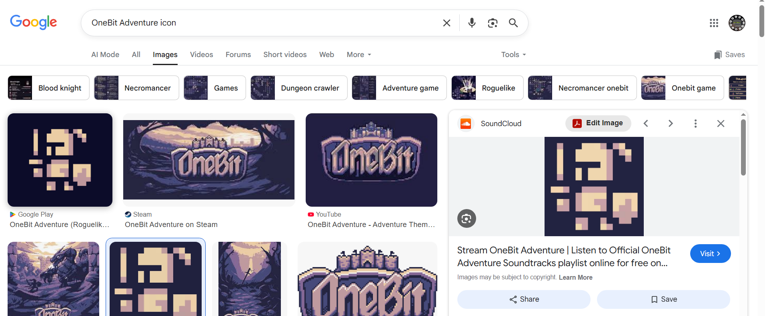

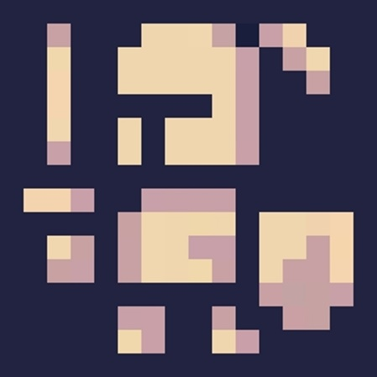

## Order of Fate

# **Source**: **Provided by** [Motasem Essam -> motasem.essam.prototypedoteg.com@gmail.com] **on** [10/9/2025]

# **Data Path**: Entities Folder -> 1-Entities Database -> 2-Persons Table -> ID: 1

**# Source: Windows Screenshots (using Lightshot Program) at [10/9/2025]**

[**https://play-lh.googleusercontent.com/sSSEiYhqbQOA5XNbN8ellfxrDkzUgoJ-7q0HKDk4PQpoSvbzww-fYgU3TIxa8Mwosw=w240-h480-rw**](https://play-lh.googleusercontent.com/sSSEiYhqbQOA5XNbN8ellfxrDkzUgoJ-7q0HKDk4PQpoSvbzww-fYgU3TIxa8Mwosw=w240-h480-rw)

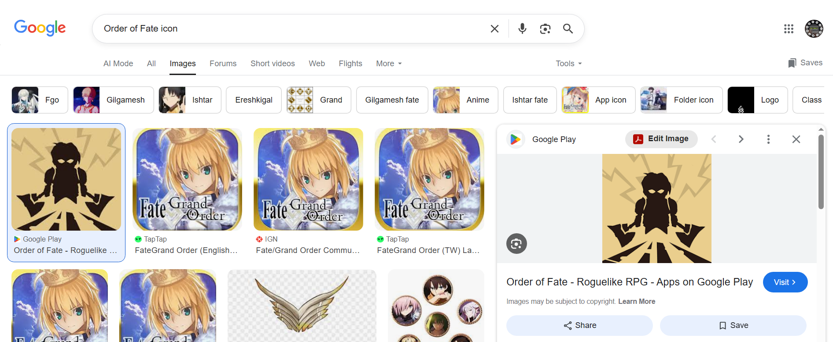



## Magic Survival

# **Source**: **Provided by** [Motasem Essam -> motasem.essam.prototypedoteg.com@gmail.com] **on** [10/9/2025]

# **Data Path**: Entities Folder -> 1-Entities Database -> 2-Persons Table -> ID: 1

**# Source: Windows Screenshots (using Lightshot Program) at [10/9/2025]**

[**https://play-lh.googleusercontent.com/no5_JZpjr1gYbfpgzjrcehn6M6LYlWVlHjPepXJ9HSNWBYa_3Ky1Fl3aEeDNdtiyCTz9**](https://play-lh.googleusercontent.com/no5_JZpjr1gYbfpgzjrcehn6M6LYlWVlHjPepXJ9HSNWBYa_3Ky1Fl3aEeDNdtiyCTz9)

